Practical-4
Practical Title: JavaScript DOM Manipulation, Event Handling, and UI Interactivity
Problem Definition Add dynamic UI components such as collapsible FAQ, modal popup, image/content slider, notification banner, hamburger menu, and light/dark theme switcher using JavaScript.

A.Theory:
1. How are DOM elements selected and modified?
Answer: DOM elements are selected using methods like document.getElementById(),querySelector(),or getElementsByClassName(), which return references to matching elements. Once selected, they can be modified by changing properties like innerHTML, textContent, style, or attributes using setAttribute(). Methods like appendChild() or remove() can add or delete elements from the DOM.
Source: MDN Web Development
2. Are event listeners attached correctly?
Answer: Yes, they are attached correctly at correct placed in JS.
Source: MDN Web Development
3. Is localStorage used for remembering theme choice?
Answer: Yes ,localStorage is used to store previous preference of user.
Source:Geeksforgeeks
4. Does interactivity improve usability without breaking accessibility?
Answer: Yes,Interactivity improves usability if we keep accessibility in mind.
Source: MDN

B.Implementation/ Output/Result
In this practical, two dynamic UI components were built by me using JavaScript DOM manipulation and event handling. For the collapsible FAQ, question elements were selected using DOM methods and click event listeners were attached to each one, toggling a CSS class that expands or collapses the corresponding answer, creating an interactive accordion-style interface. For the light/dark theme switcher, a toggle button was used to add or remove a class on the body element to switch between themes, while the user's selected preference was saved in localStorage so that it persists and is automatically reapplied when the page is reloaded.
C.Evidence Of Work(Screenshots):
1)Home Page:
Light Mode:
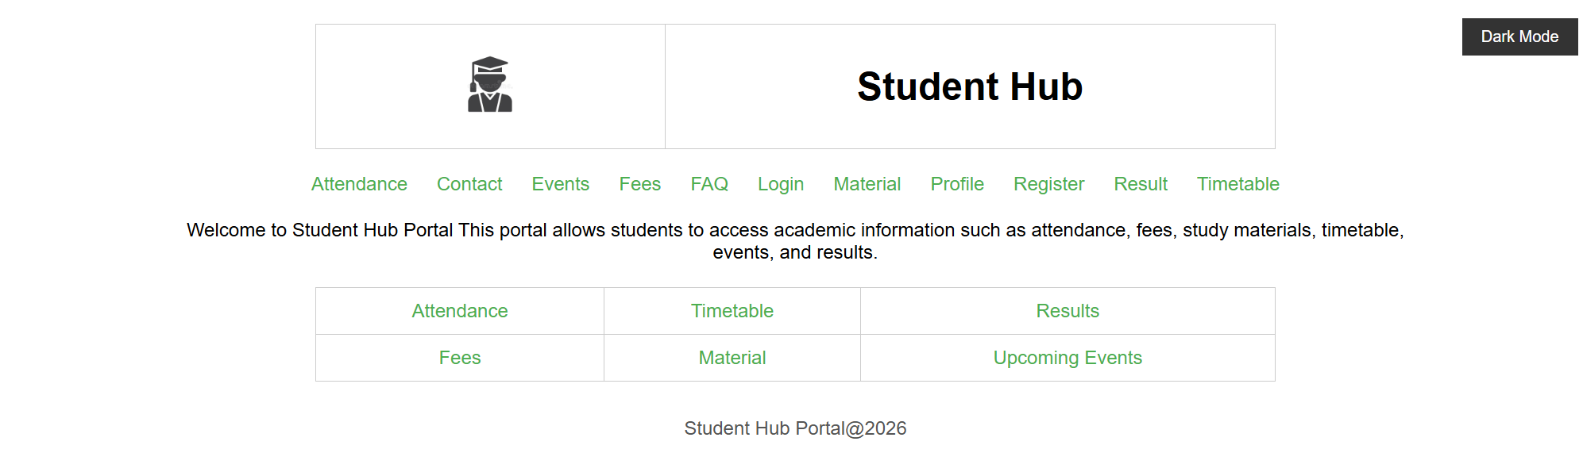

Dark Mode:
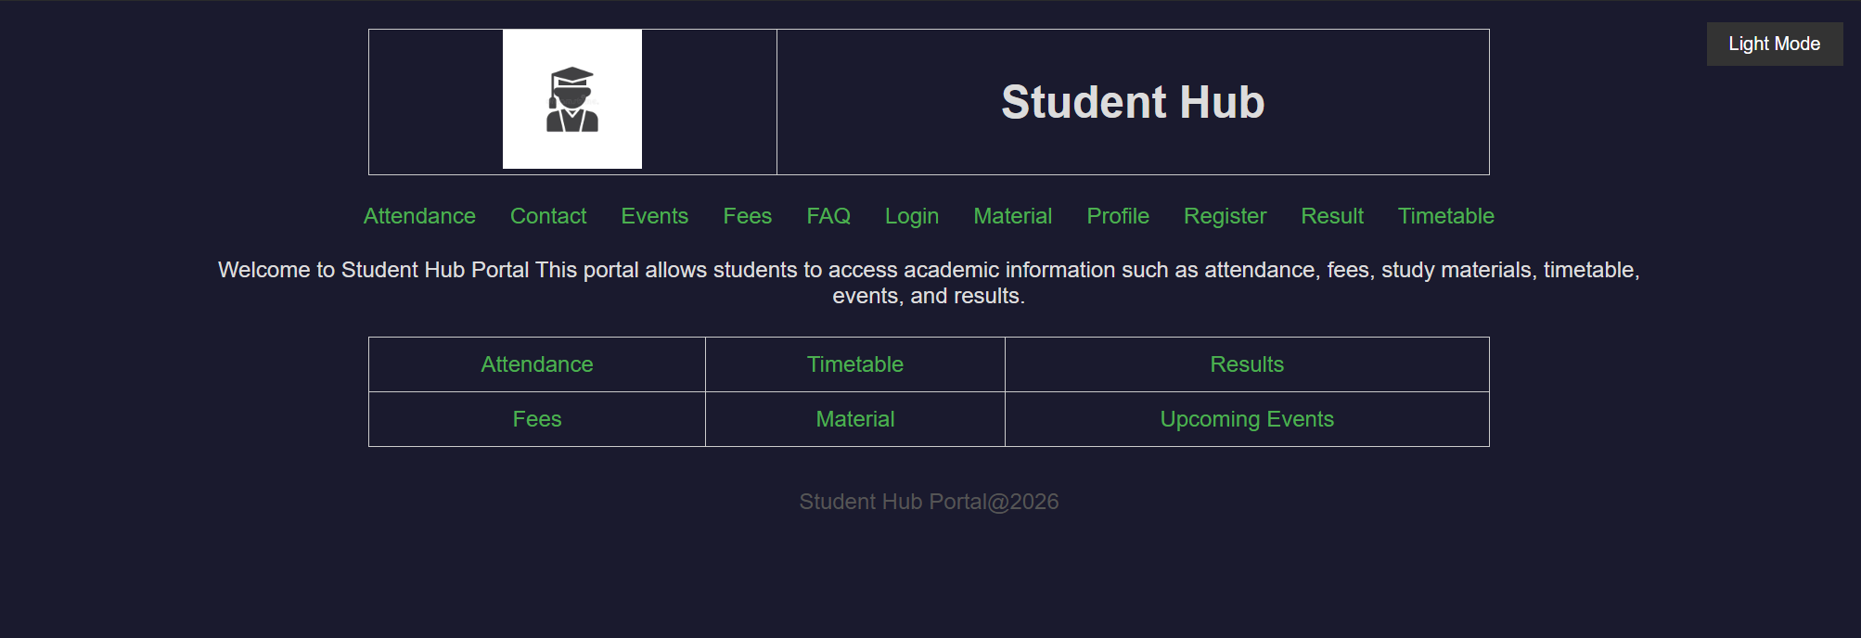

2)Attendance Page:
Light Mode:
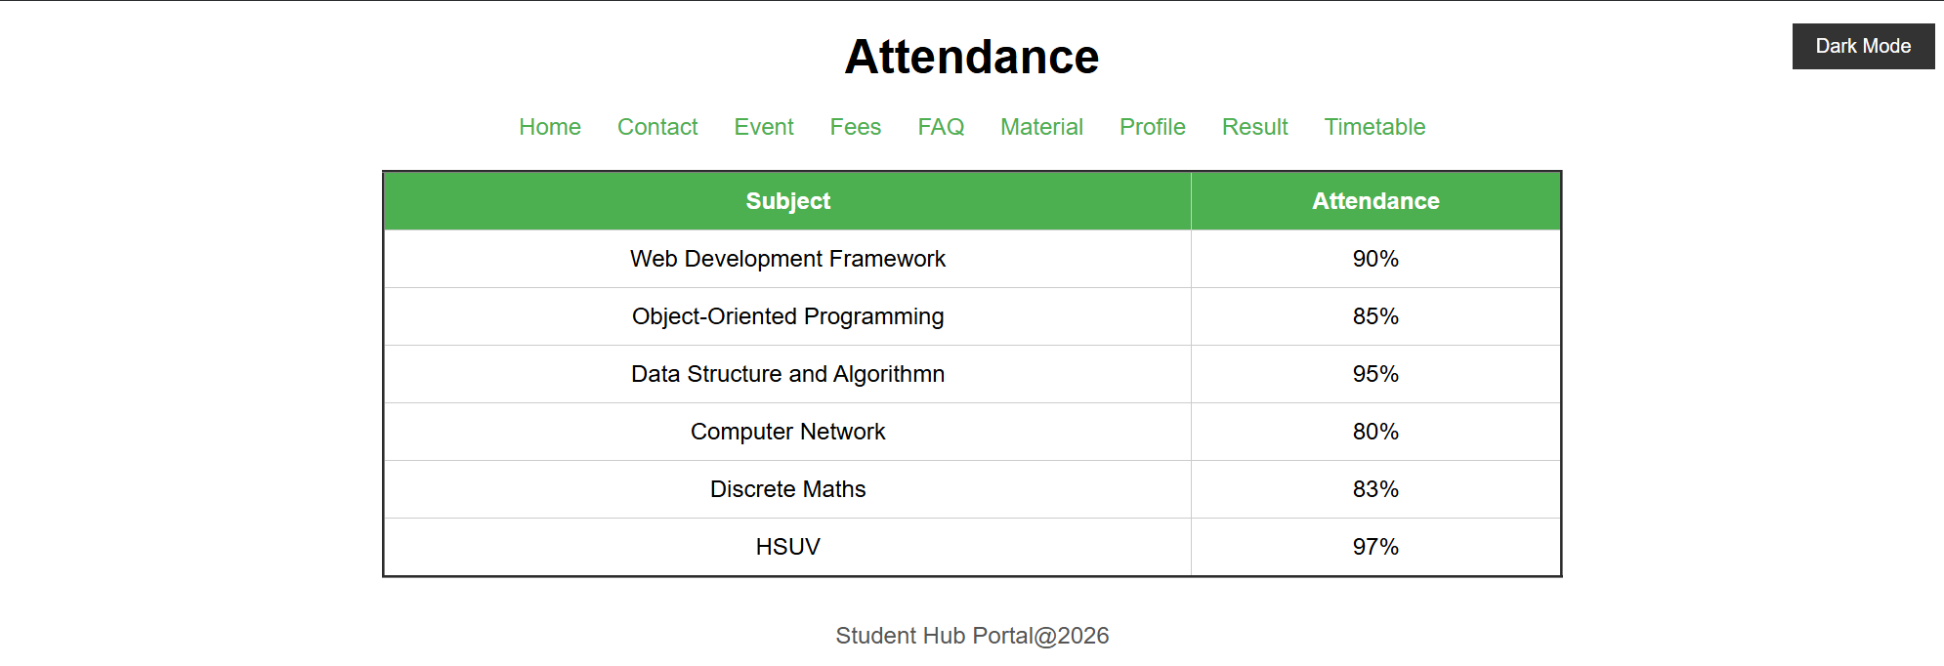
Dark Mode:
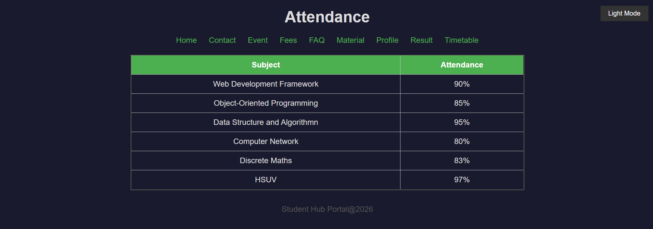
3)Contact Page:
Light Mode:
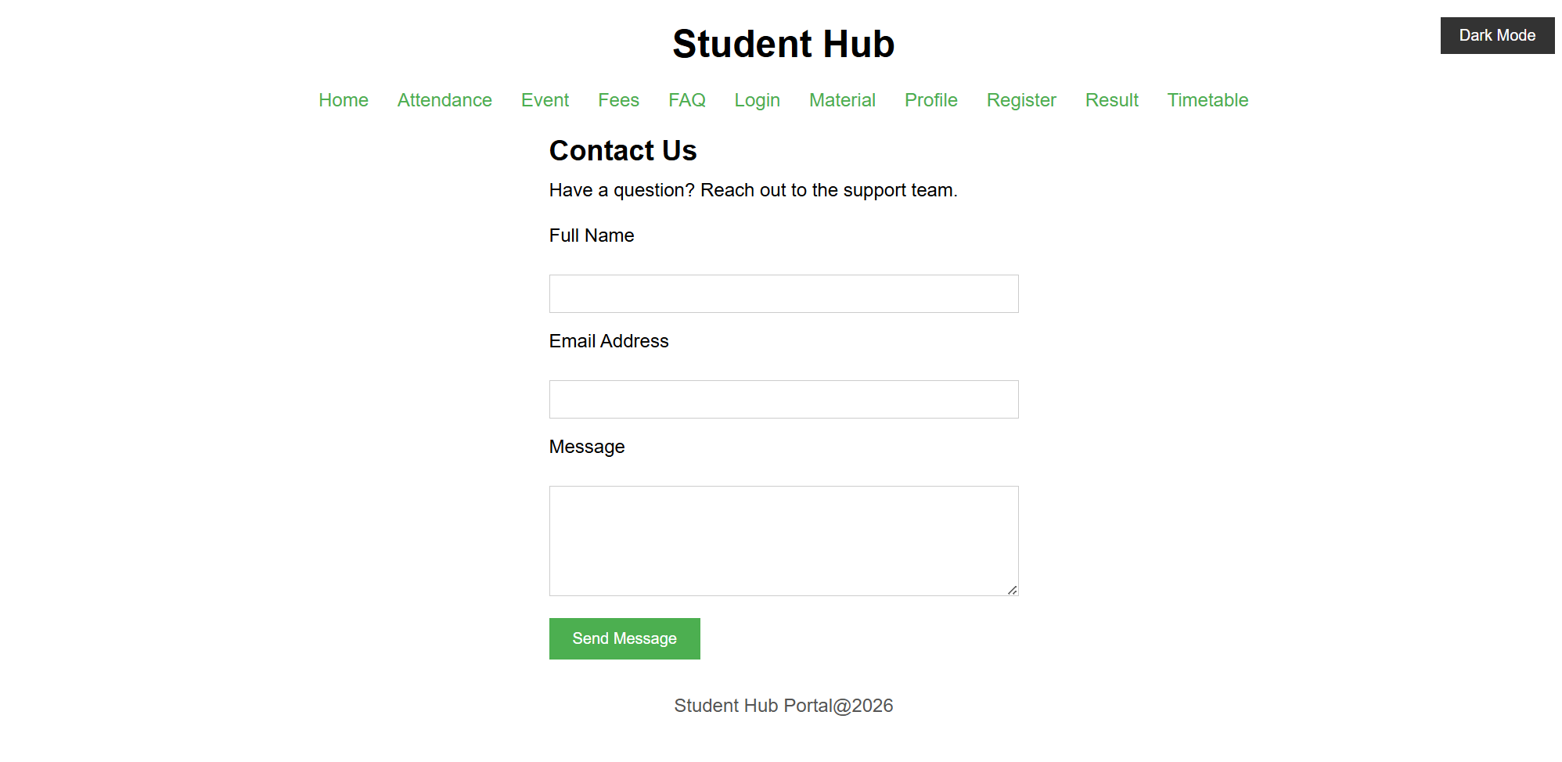
Dark Mode:
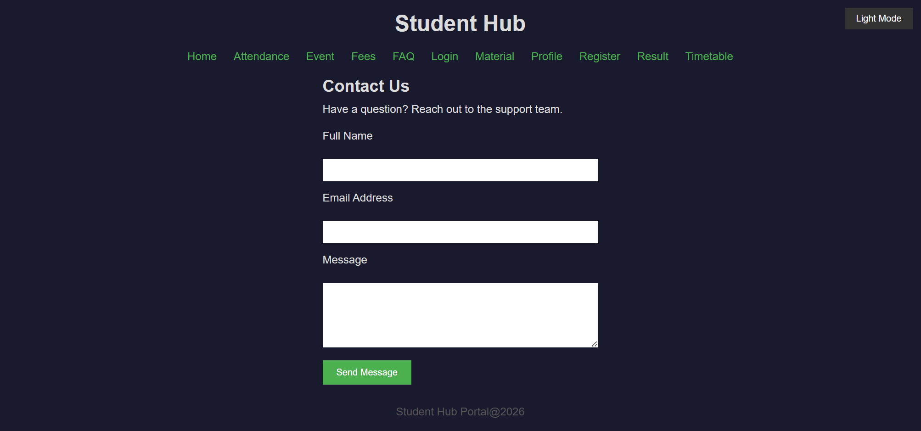

4)Details(Event) Page:
Light Mode:
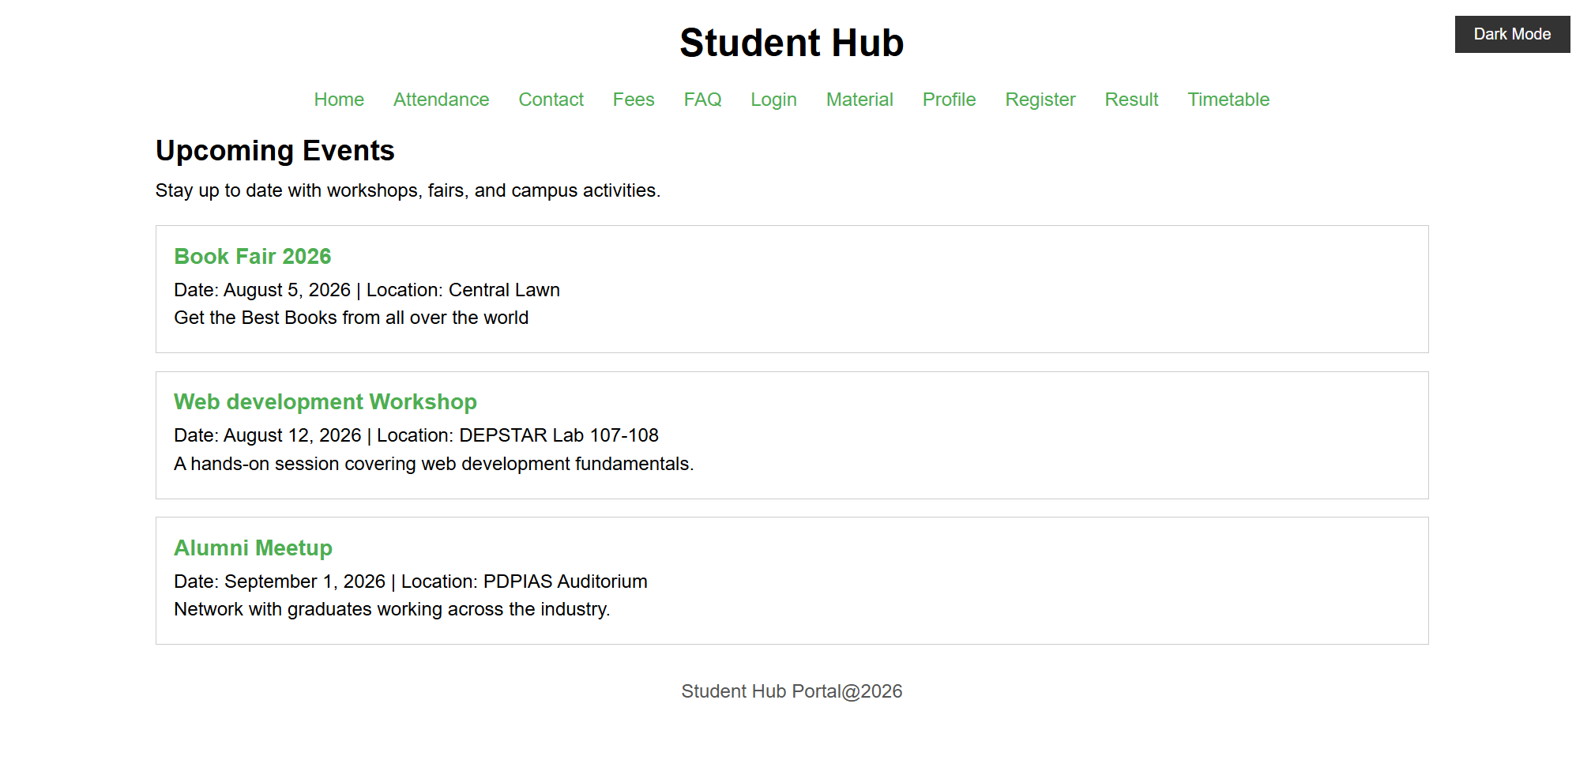
Dark Mode:
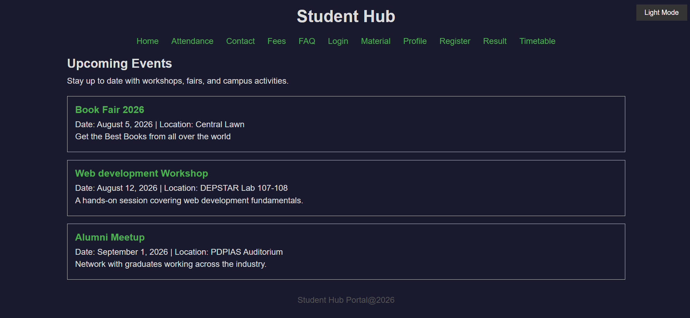

5)Fees Page:
Light Mode:
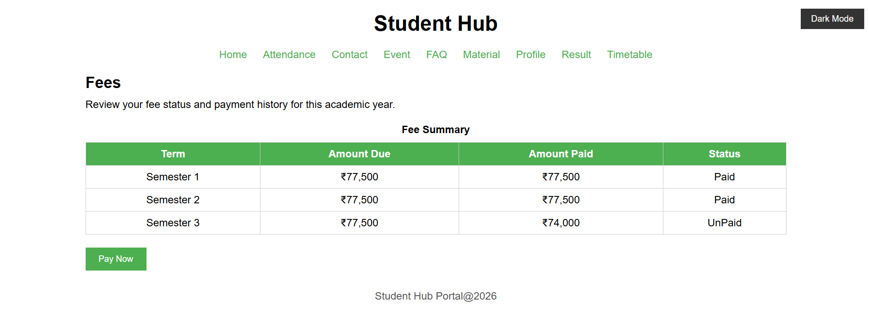
Dark Mode:
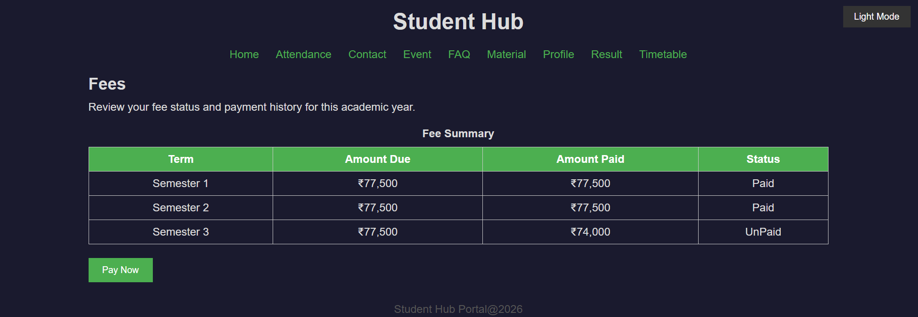

6)Material Page:
Light Mode:
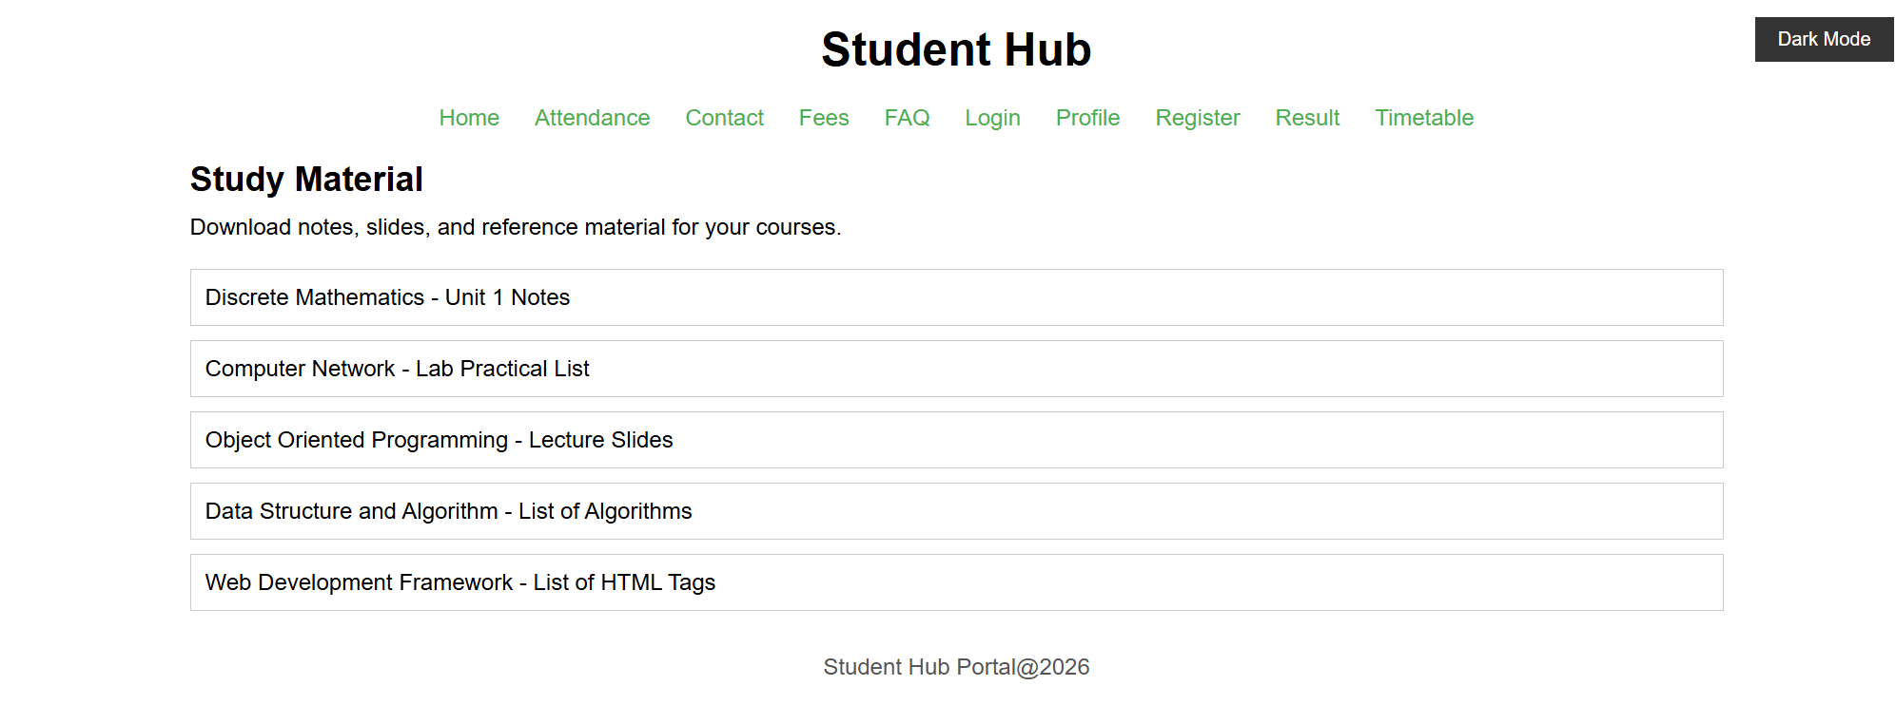
Dark Mode:
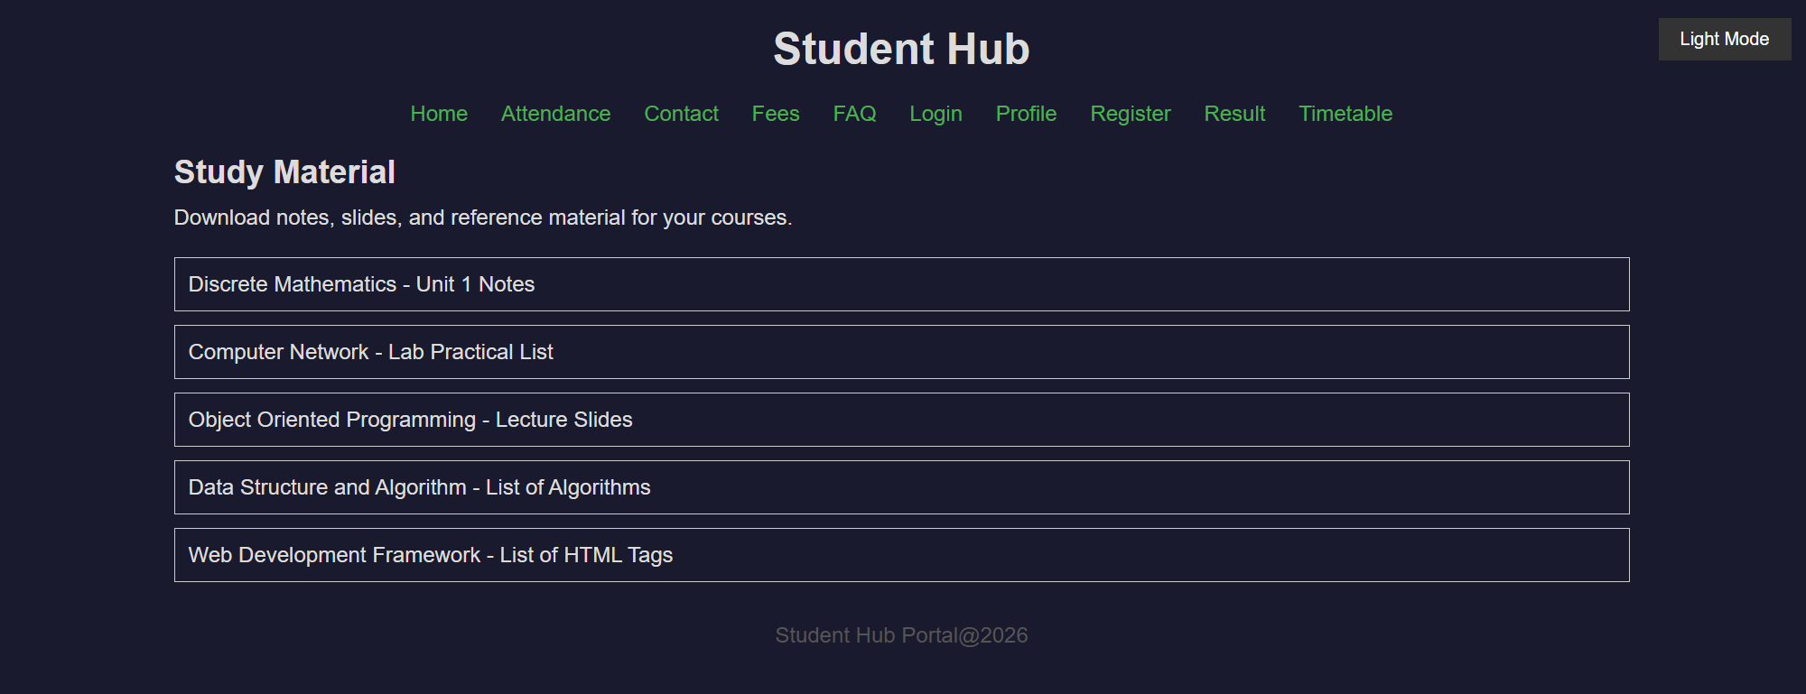

7)Profile Page:
Light Mode:
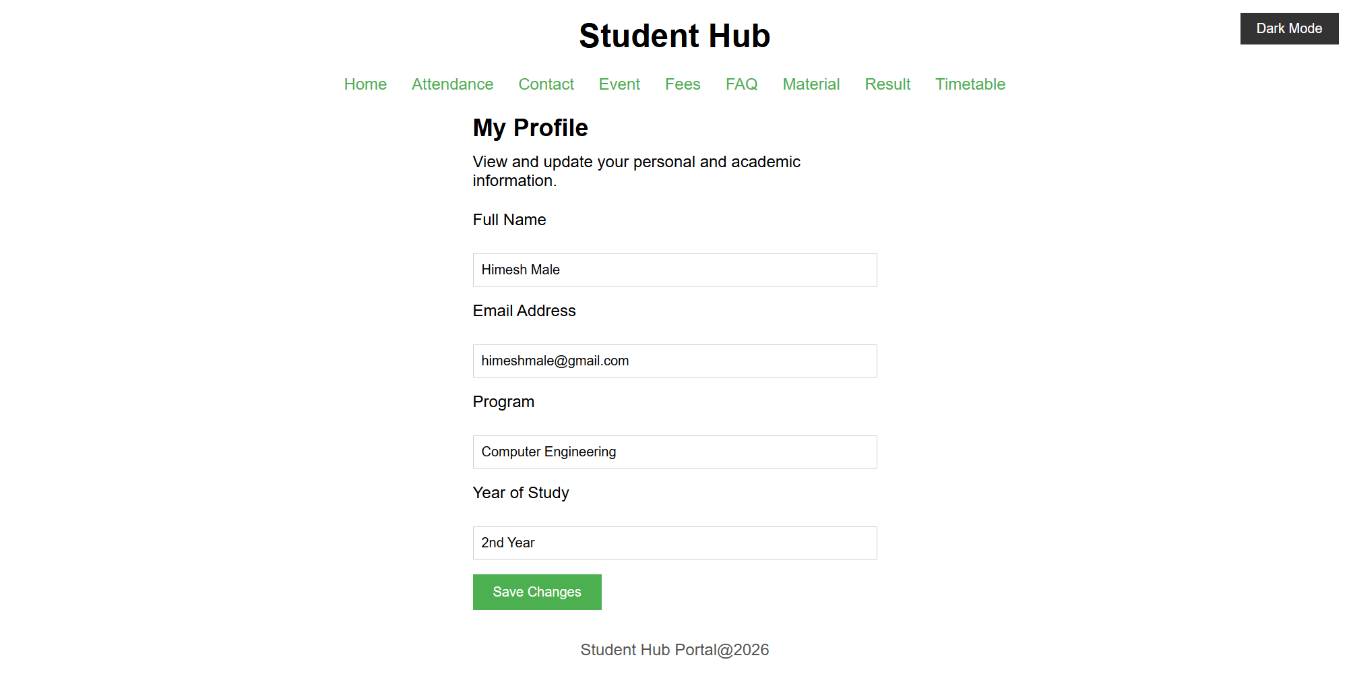
Dark Mode:
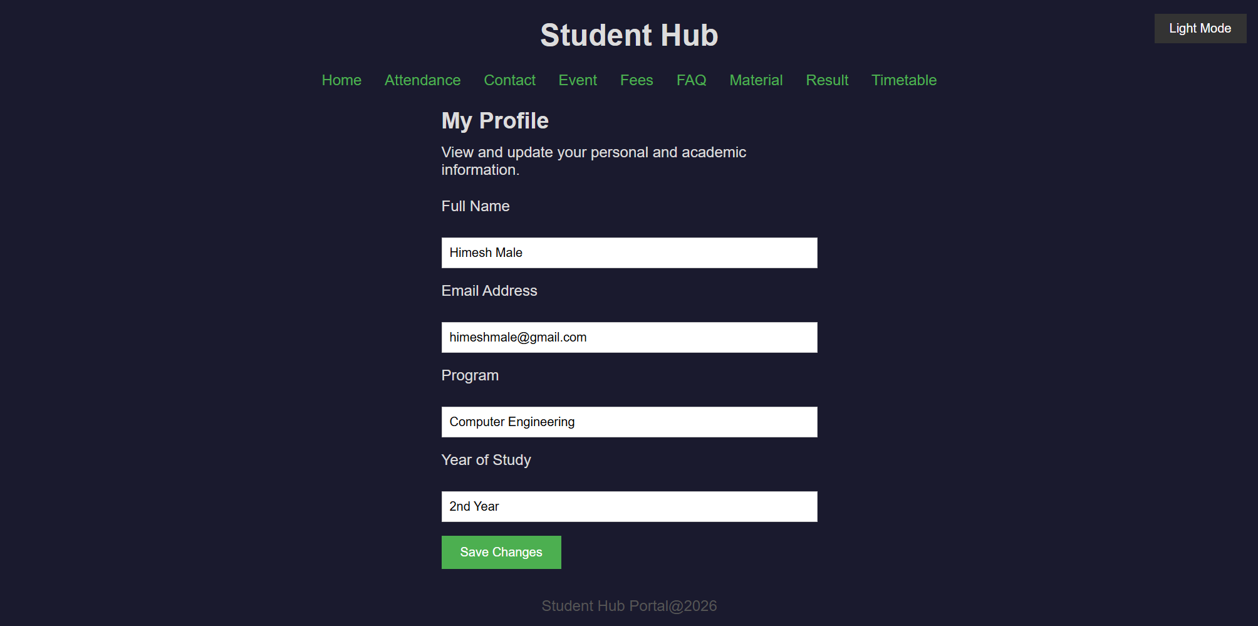

8)TimeTable:
Light Mode:
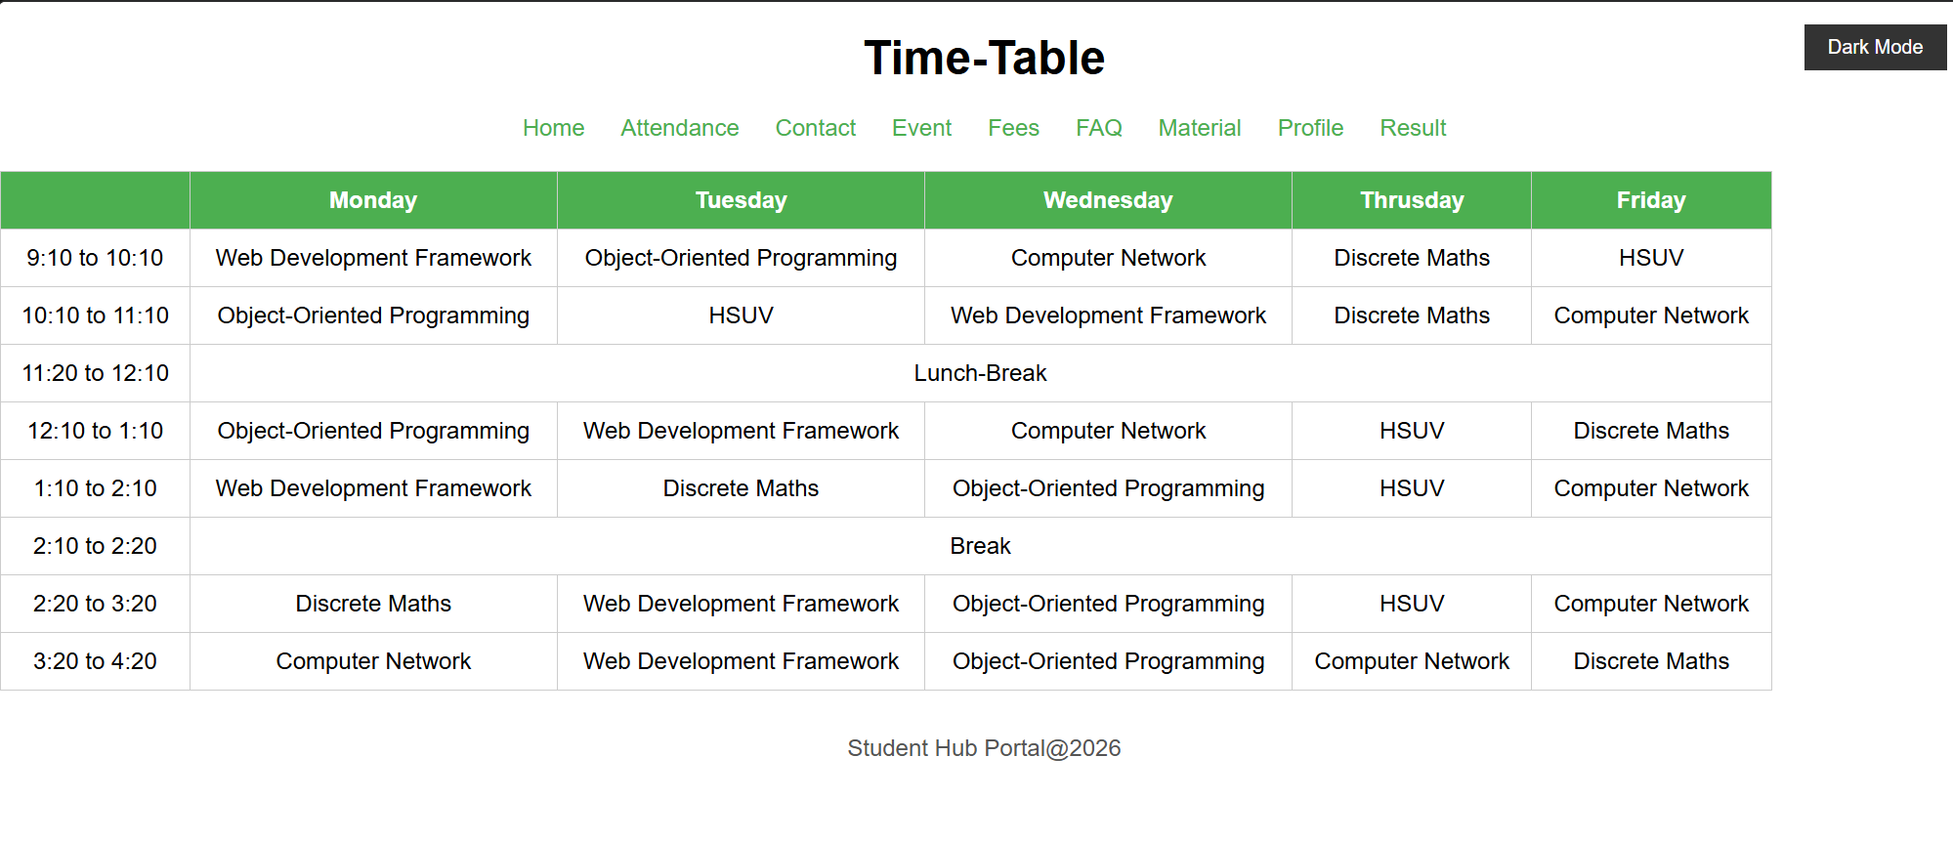
Dark Mode:
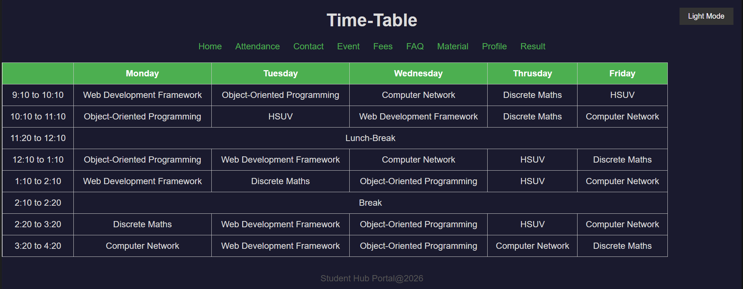

9)FAQ:
Light Mode:
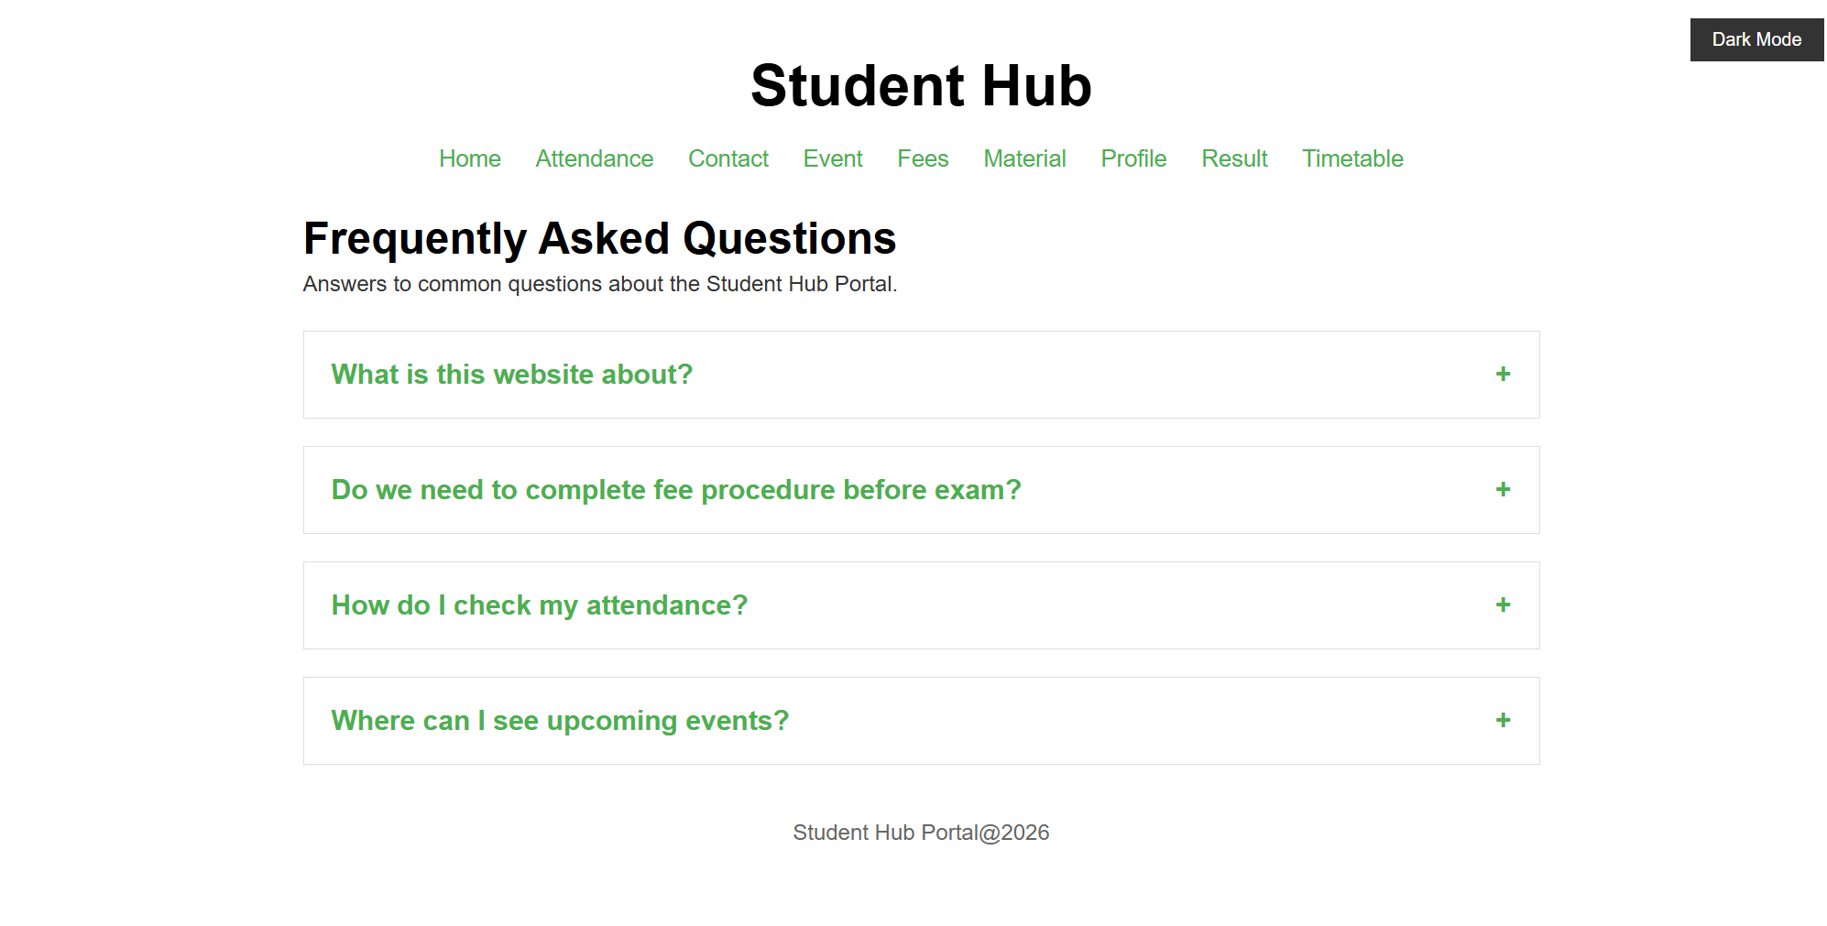
Dark Mode:
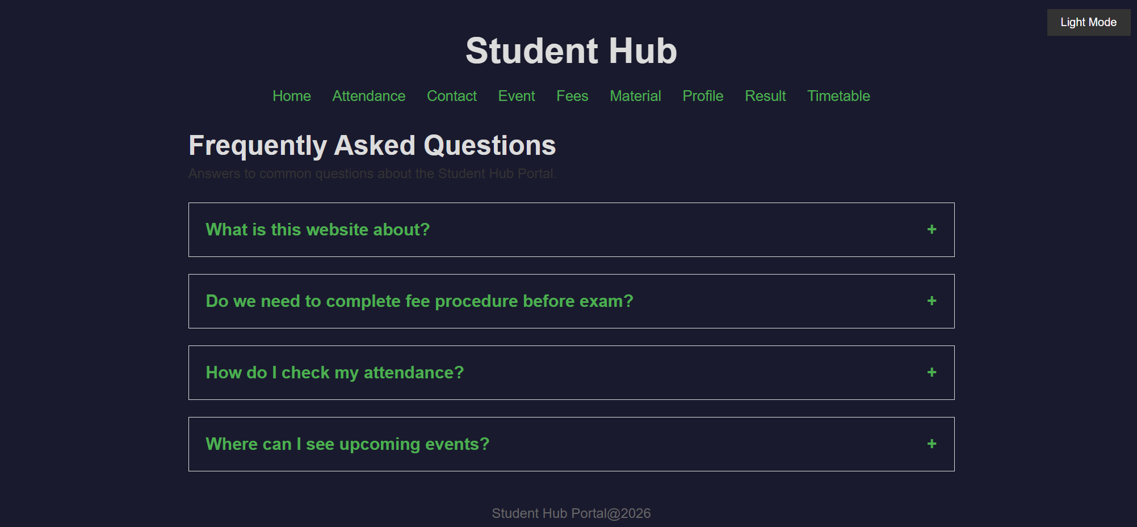

Collapsible FAQ:
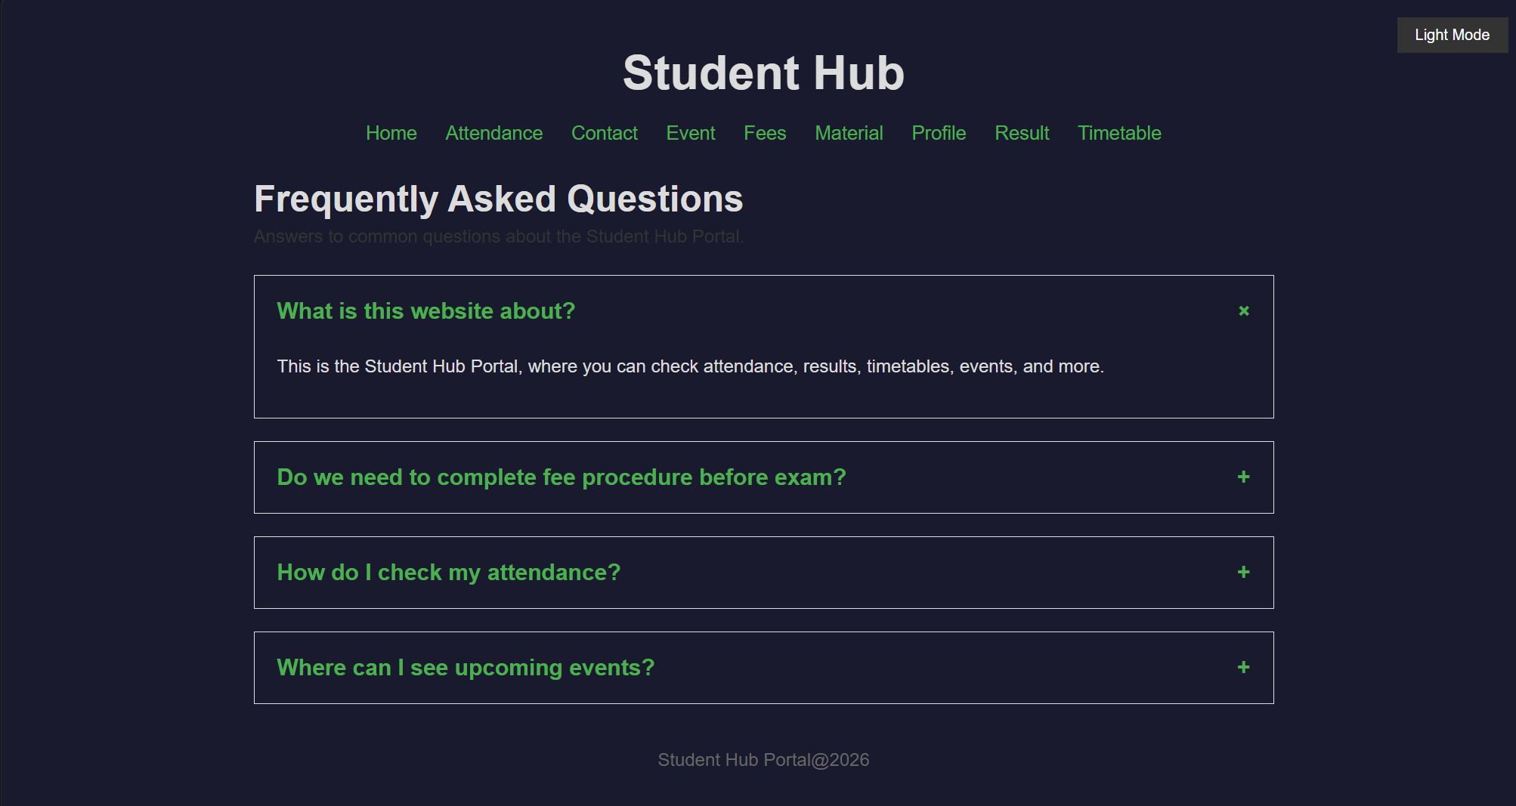
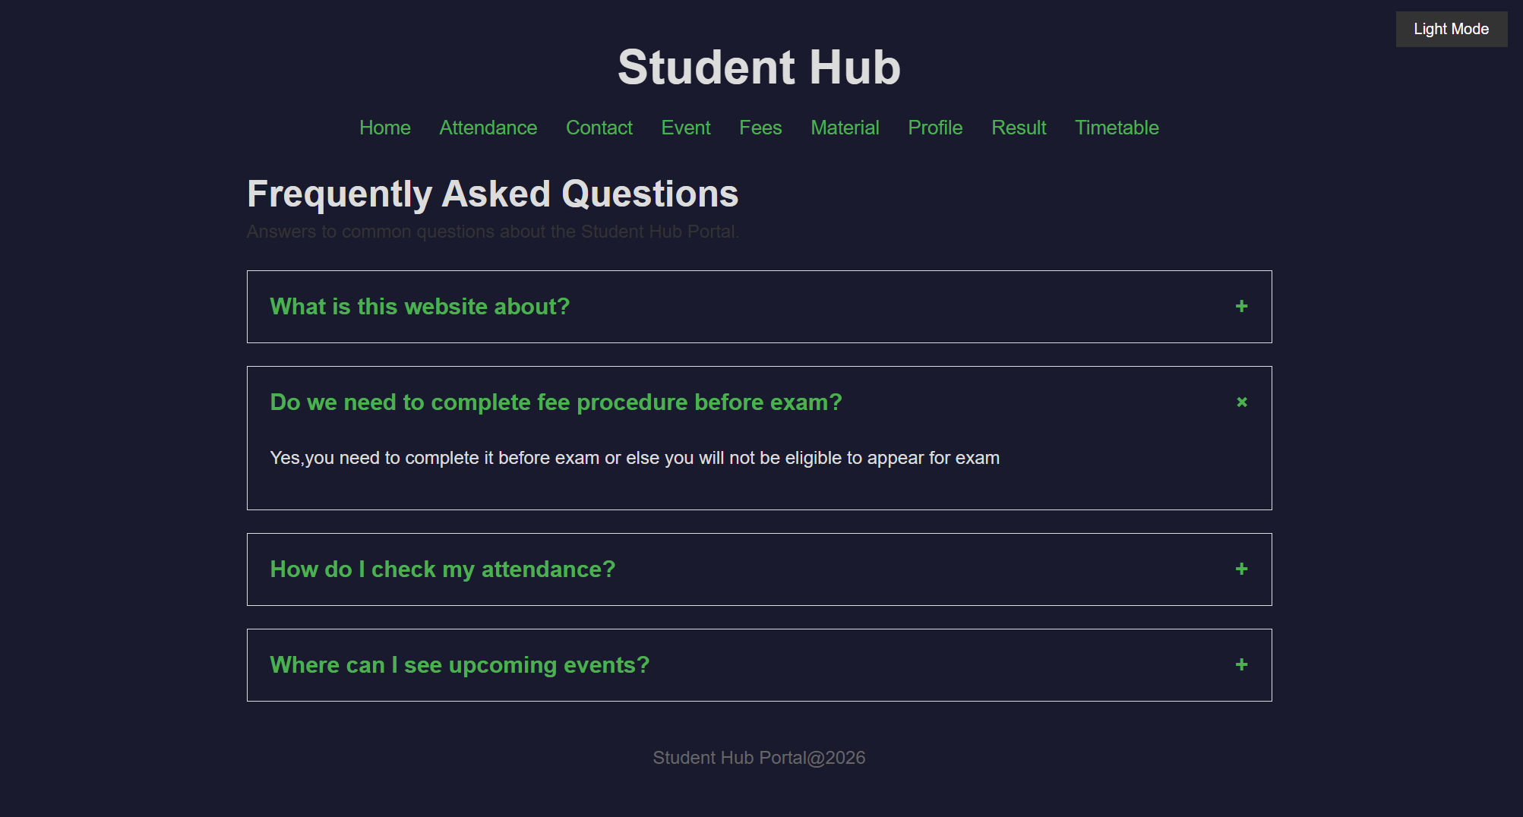

D. GitHub Repository Link: https://github.com/HimeshMale/Student-Hub-Portal.git

E. Challenge Faced:
A common challenge was handling event listeners correctly ,since elements added dynamically to the DOM don't automatically have listeners attached to them, event delegation had to be used instead of directly binding listeners to individual elements. Another challenge was properly managing class manipulation methods like classList.add(), toggle(), and remove(), as mixing these up often led to inconsistent UI states, such as FAQ answers not collapsing correctly or the toggle behavior breaking after repeated clicks.
F. Learning Outcomes:
Through this practical, I learned how to select and manipulate DOM elements dynamically using JavaScript, attach and manage event listeners for user interactions, and control UI state through class manipulation. I also gained practical experience using localStorage to store and retrieve user preferences, enabling persistent behavior like remembering theme choices across page reloads.
Faculty Remarks:

